Use the following description and screen shot to write minimum 10 Test cases in Proper Format also marked Functional, Nonfunctional, Positive and Negative cases? identify minimum 05 bugs? Identify at-least 03 suggestions for improvements
Description: Registration form having form name “Sign Up Form”, First Name and Email Address are mandatory fields, email should be in proper format and Name and Last Name should be limited to 20 characters. There would be some checkboxes for allergies and other text box if user don’t want to select any allergy. Date Time picker should be in the format “MM/DD/YYYY”, Submit will submit the form and Cancel Button will reset all data. (Note: Make sure to focus on test coverage)
<input type="text" id="fname" name="name" required> <input type="text" id="name" name="lname" required>
<input type="text" name="email" required>
<input type="text" type="DatePicker" name=" " > Birthdate
<input type="checkbox"> Gluten
<input type="checkbox"> Lactose
<input type="checkbox"> Peanuts
<input type="checkbox"> Other:
<input type="text" name="Alergies">
<button type="button” class="submitButton">Add Question</button>
<button type="submit" class="signupbtn" id="cancelButton">Add Section Heading</button>

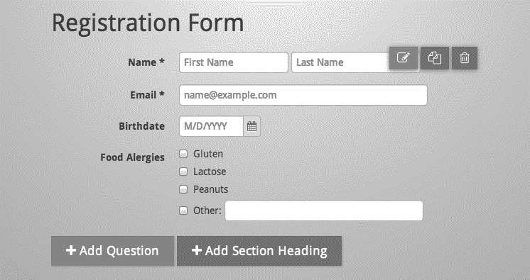

Task 1 – Registration Form Testing
Requirements (from the document):
- Form Name: Sign Up Form
- First Name and Email are mandatory.
- Email must be in proper format.
- First Name and Last Name maximum length is 20 characters.
- Date format: MM/DD/YYYY
- Submit submits the form.
TC ID | Test Scenario | Steps | Expected Result | Type | Positive/Negative
TC-01 | Verify successful registration | Enter valid data and click Submit | Form submitted successfully | Functional | Positive
TC-02 | Verify First Name mandatory | Leave First Name blank and Submit | Validation message displayed | Functional | Negative
TC-03 | Verify Email mandatory | Leave Email blank and Submit | Validation message displayed | Functional | Negative
TC-04 | Verify valid email format | Enter user@test.com | Email accepted | Functional | Positive
TC-05 | Verify invalid email format | Enter user@test | Error message shown | Functional | Negative
TC-06 | Verify First Name length | Enter more than 20 characters | Validation displayed | Functional | Negative
TC-07 | Verify Last Name length | Enter more than 20 characters | Validation displayed | Functional | Negative
TC-08 | Verify Birthdate format | Select date in MM/DD/YYYY | Date accepted | Functional | Positive
TC-09 | Verify Cancel button | Enter data then click Cancel | All fields reset | Functional | Positive
TC-10 | Verify page performance | Load registration page | Page loads within acceptable time | Non-Functional | Positive

Identify 5 Bugs
Bug ID | Title | Severity | Expected | Actual
BUG-01 | Submit button label incorrect | High | Button should display Submit | Displays Add Question
BUG-02 | Cancel button label incorrect | High | Button should display Cancel | Displays Add Section Heading
BUG-03 | Duplicate "type" attribute | Medium | Single valid input type | Input contains two type attributes
BUG-04 | Birthdate input incorrect | High | type="date" | Uses invalid DatePicker syntax
BUG-05 | Last Name field ID incorrect | Low | Unique meaningful ID | Uses generic/duplicate ID naming
Suggestions (3)
- Replace incorrect button labels with Submit and Cancel.
- Use HTML5 validation (type="email" and type="date").
- Display clear validation messages beside invalid fields.

Write TEN Test cases and automate one positive and one negative case with assertion. Also suggest at least FIVE improvements
Requirements:
• The First and Last Name text boxes are mandatory parameters,
• The name box can have only A-z and A-Z characters. No numbers, or special characters are allowed.
• Names can be a maximum of 10 characters long.
• The Email ID must accept alphanumeric characters, no special characters are allowed.
• Email ID can be a maximum of 15 characters long.
• The Email ID is mandatory.

Note: Used proper template for test case writing and you can assume locators based on screenshot;
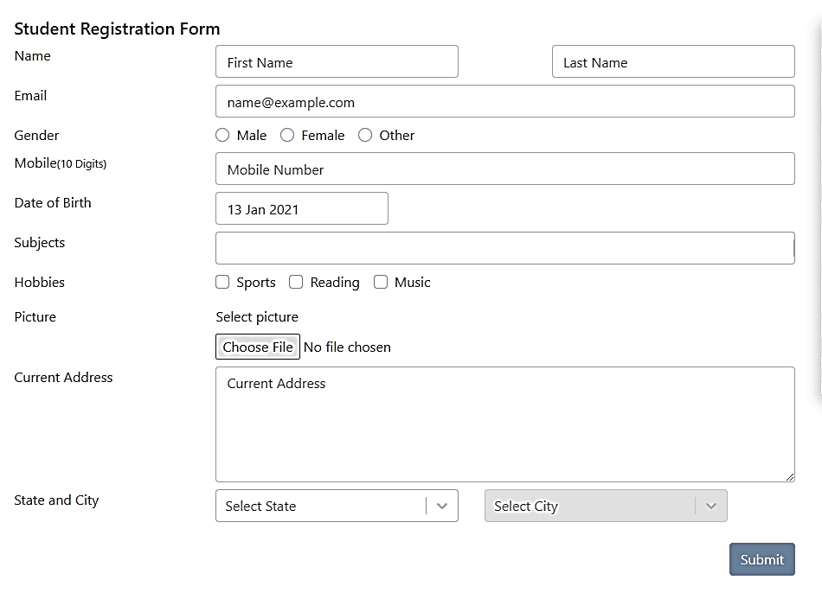

Task 2 – Name & Email Validation
Requirements: First Name, Last Name, and Email are mandatory. Names accept only A–Z/a–z, maximum 10 characters. Email accepts alphanumeric characters and maximum 15 characters.
TC ID | Test Scenario | Expected Result | Type | Positive/Negative
TC-01 | Valid Name and Email | Registration successful | Functional | Positive
TC-02 | Empty First Name | Validation shown | Functional | Negative
TC-03 | Empty Last Name | Validation shown | Functional | Negative
TC-04 | Empty Email | Validation shown | Functional | Negative
TC-05 | Name with numbers | Rejected | Functional | Negative
TC-06 | Name with special characters | Rejected | Functional | Negative
TC-07 | Name longer than 10 characters | Rejected | Functional | Negative
TC-08 | Email longer than 15 characters | Rejected | Functional | Negative
TC-09 | Valid maximum length values | Accepted | Functional | Positive
TC-10 | Page response after Submit | Response received quickly | Non-Functional | Positive
Five Improvements
- Use type="email" instead of type="text" for Email.
- Add real-time validation.
- Show validation messages below each field.
- Disable Submit until mandatory fields are valid.
- Add accessibility labels and placeholders.

Following is the case study of an organization at the team level as well as at the process level. You have been hired as a Quality Assurance Expert for process improvement. You need to do the following things:

- Identify the main reasons for failures? And Redefine the process

CASE STUDY:

There are too many juniors in an engineering team. Usually, they have no or little experience with Agile methodologies. Hence, they hardly can live up to processes, particularly they fail to say “No.” Tasks are discussed on pull requests once they're finished, but not in advance during grooming or sprint planning sessions. Team is only working on frontend issues and lacks backend competence. That team will always rely on another team delivering functionality to build upon.
Product owner and Scrum master role is assigned to same person. Team members reject agile methodologies openly, as they do not want to be pushed out of their comfort zones. Teams are not self-organizing. That would require accepting responsibility for the team’s performance and a sense of urgency for delivery and value creation. Even worse, team members abandon Agile quietly, believing it is a management fad that will go away sooner or later. Teams follow the “Agile rules” mechanically without understanding why those are defined in the first place. There is no improvement over the previous process, despite all Agile rules are being followed to the letter. Or even worse: morale and productivity go down, as the enthusiasm after the initial agile training wears off quickly in the trenches. Moving people among teams upon short notice. Even if required for technical reasons, this has a negative impact on a team's performance & morale.
Stakeholders are bypassing product management to get things done and get away with it in the eyes of the senior management, as they would show initiative. The organization is not spending enough time on team communication and workshops to create a shared understanding of what is to be built. A team is not co-located, not working in the same room, but scattered across different floors, or worse, different locations. The work environment is lacking spots for formal and – more important – informal communication: cafeterias, tea kitchens, sofas, etc. The work environment is lacking whiteboards. The absence of whiteboards on every available wall within the office should be questionable, not having them. Agile requires suitable offices to further collaboration: spacy, with plenty of air and light. But they should not be a mere open space, which tends to get too noisy, particularly when several Scrum teams have stand-ups at the same time.

Task 3 – Case Study
Main Reasons for Failures
Based on the case study:
- Too many junior engineers with little Agile knowledge.
- No proper grooming or sprint planning.
- Frontend-only expertise; dependency on another team for backend.
- Product Owner and Scrum Master roles combined.
- Team resists Agile practices.
- Teams are not self-organizing.
- Frequent movement of developers between teams.
- Poor communication with stakeholders.
- Distributed teams with inadequate collaboration.
- Poor office environment (lack of whiteboards and collaboration spaces).
Redefined Process
- Separate the Product Owner and Scrum Master roles.
- Train all team members on Agile and Scrum.
- Conduct regular backlog refinement and sprint planning.
- Build cross-functional teams with frontend and backend skills.
- Encourage self-organization and accountability.
- Keep team membership stable during sprints.
- Improve stakeholder communication through the Product Owner.
- Hold Daily Scrum, Sprint Review, and Retrospective meetings consistently.
- Provide collaboration tools, whiteboards, and suitable workspaces.
- Track quality with sprint metrics, defect trends, code reviews, and automated testing.
This completes the assignment requested in the uploaded document.

